***Assignment 2***

***DBMS LAB***

**NAME-Ashish Goyal**

**ID-2016ucp1100**

**BATCH –A 1, 2**

1. Create database and create table Salesman.

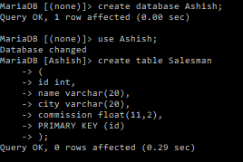

1. create table customer

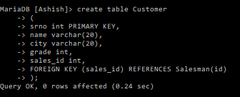

1. create table orders

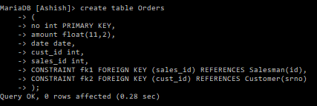

1. insert values in the salesman

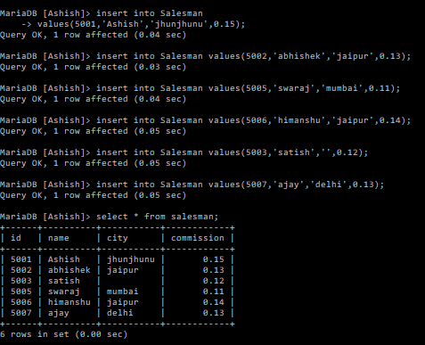

1. insert values in the customer

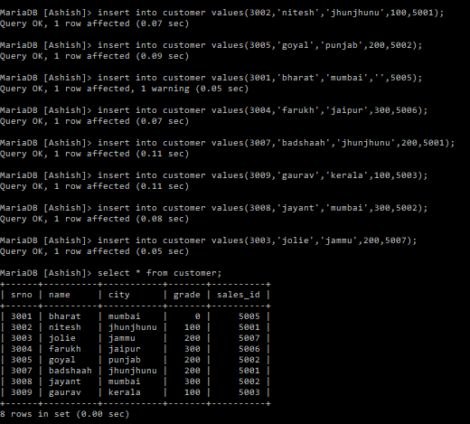

1. insert values in the order

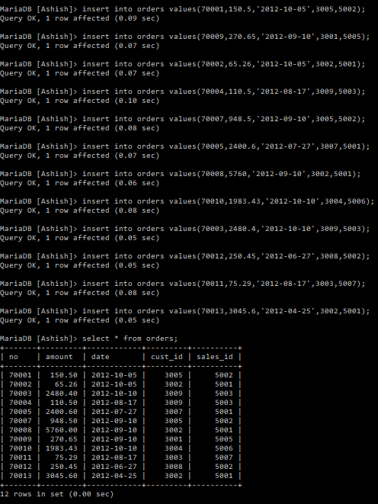

Qwery1) Write a SQL statement to prepare a list with salesman name, customer name and their cities for the salesmen and customer who belongs to the same city.

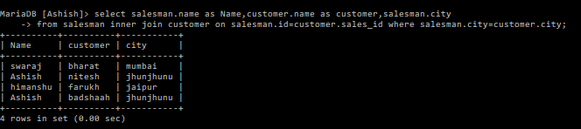

Query2) Write a SQL statement to find the list of customers who appointed a salesman for their jobs who does not live in the same city where their customer lives.

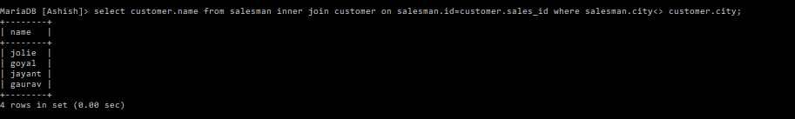

Query3) Write a SQL statement to know which salesman are working for which customer.

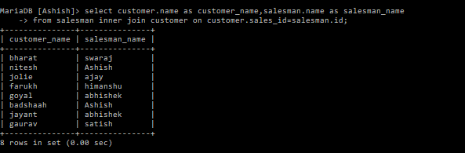

Query4) Write a SQL statement to make a list with order no, purchase amount, customer name and their cities for those orders which order amount between 500 and 2000.

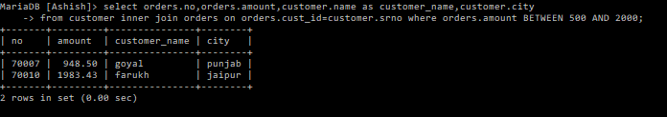

Query5) Write a SQL statement to find the list of customers who appointed a salesman for their jobs who gets a commission from the company is more than 12%.

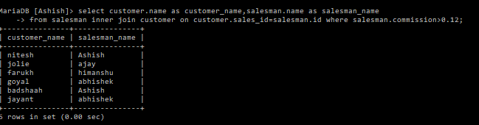

Query6) Write a SQL statement to find the details of a order i.e. order number, order date, amount of order, which customer gives the order and which salesman works for that customer and how much commission he gets for an order.

